Exercise: Peg Solitaire

You can search online for the solution or the code if you’d like. The fastest this program can be written is maybe 3 days (36 hours).

Difficulty level: 4 out of 5

This game only needs one player which is the computer.

You start the game with the marble board like shown below with all the holes are filled except the hole in the very middle where it’s empty. The goal is to make valid moves and end with one marble in the center of the marble board.

A valid move is for a marble to jump over an adjacent marble into an empty hole that is two positions away and to remove the marble that it jumped over.

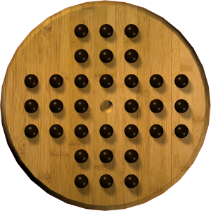

If you can end with just one marble in the center of the board, then you get a 100%.

It’s minus 5% if the marble ends up not being in the middle of the board.

It’s additional minus 5% for every additional marble that is left.

So if the program ends up with 2 marbles left, you get 90%.